|  |  |  |
| --- | --- | --- |
| January 2020 | Children’s Chorus of Carroll County | [www.ccccnotes.com](http://www.ccccnotes.com) |

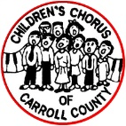

**The HummingBird**

**The Daly Review:**

December gave us five beautiful concerts that brought wonderful holiday cheer for all to hear! Right before the December excitement, we had students and parents participate in the Electric Miracle on Main St. Parade that was SO MUCH FUN! As you can see below, they walked Main St. as glowing stick figures and their voices sang carols the whole length of the parade. Thank you to the families who did some holiday shopping during our Vendor Night on Dec 3rd! Each vendor donated a percentage of their sales back to the Chorus and we are so very grateful for your participation. The BC2s knocked the socks off of the Big Band Merry Christmas audience members! The man in charge of this event wrote to Rachel Im saying the BC2s were, “…well prepared and made our final rehearsal and sound check very easy for me to feel comfortable with what the actual performance would be. Please give my sincere thanks to your students.” The LPVs brought many smiles to both residents and workers at the Lorien the same day and got any nervous jitters out about the December Program. The next day, our DBs sang for the Grace Lutheran Church Service and you can see below that there was an added bonus to their beautiful performance that day! About 15 people sang for the Taneytown Business Breakfast and this brought in a bountiful donation for the Chorus. Thank you for those of you who sang carols on that early morning!! And boy, oh, boy, what a beautiful concert on December 15th! The music was gorgeous, the soloists impressive, the guest musicians were spot on, and our Alumni Presence is growing! Our Team works so hard all semester to produce such a beautiful display of our organization. Thank you, all!

**A Note from Pastor Martha:**

Pastor Martha of our home, Grace Lutheran Church, would like to thank all of the families who contributed to the gift bags for the Table of Grace guests. Grace had an awesome number of bags this year and it was greatly due to the fact that many of the Chorus families took a bag when they worshipped and performed on December 8. Some families asked for a bag after the service. Grace is very grateful for the support for this important ministry. Those who received bags with warm socks and gloves, personal items and the treat of a candy bar were very thankful for the gifts.

**Miracle on Main St. Parade Crowd:**

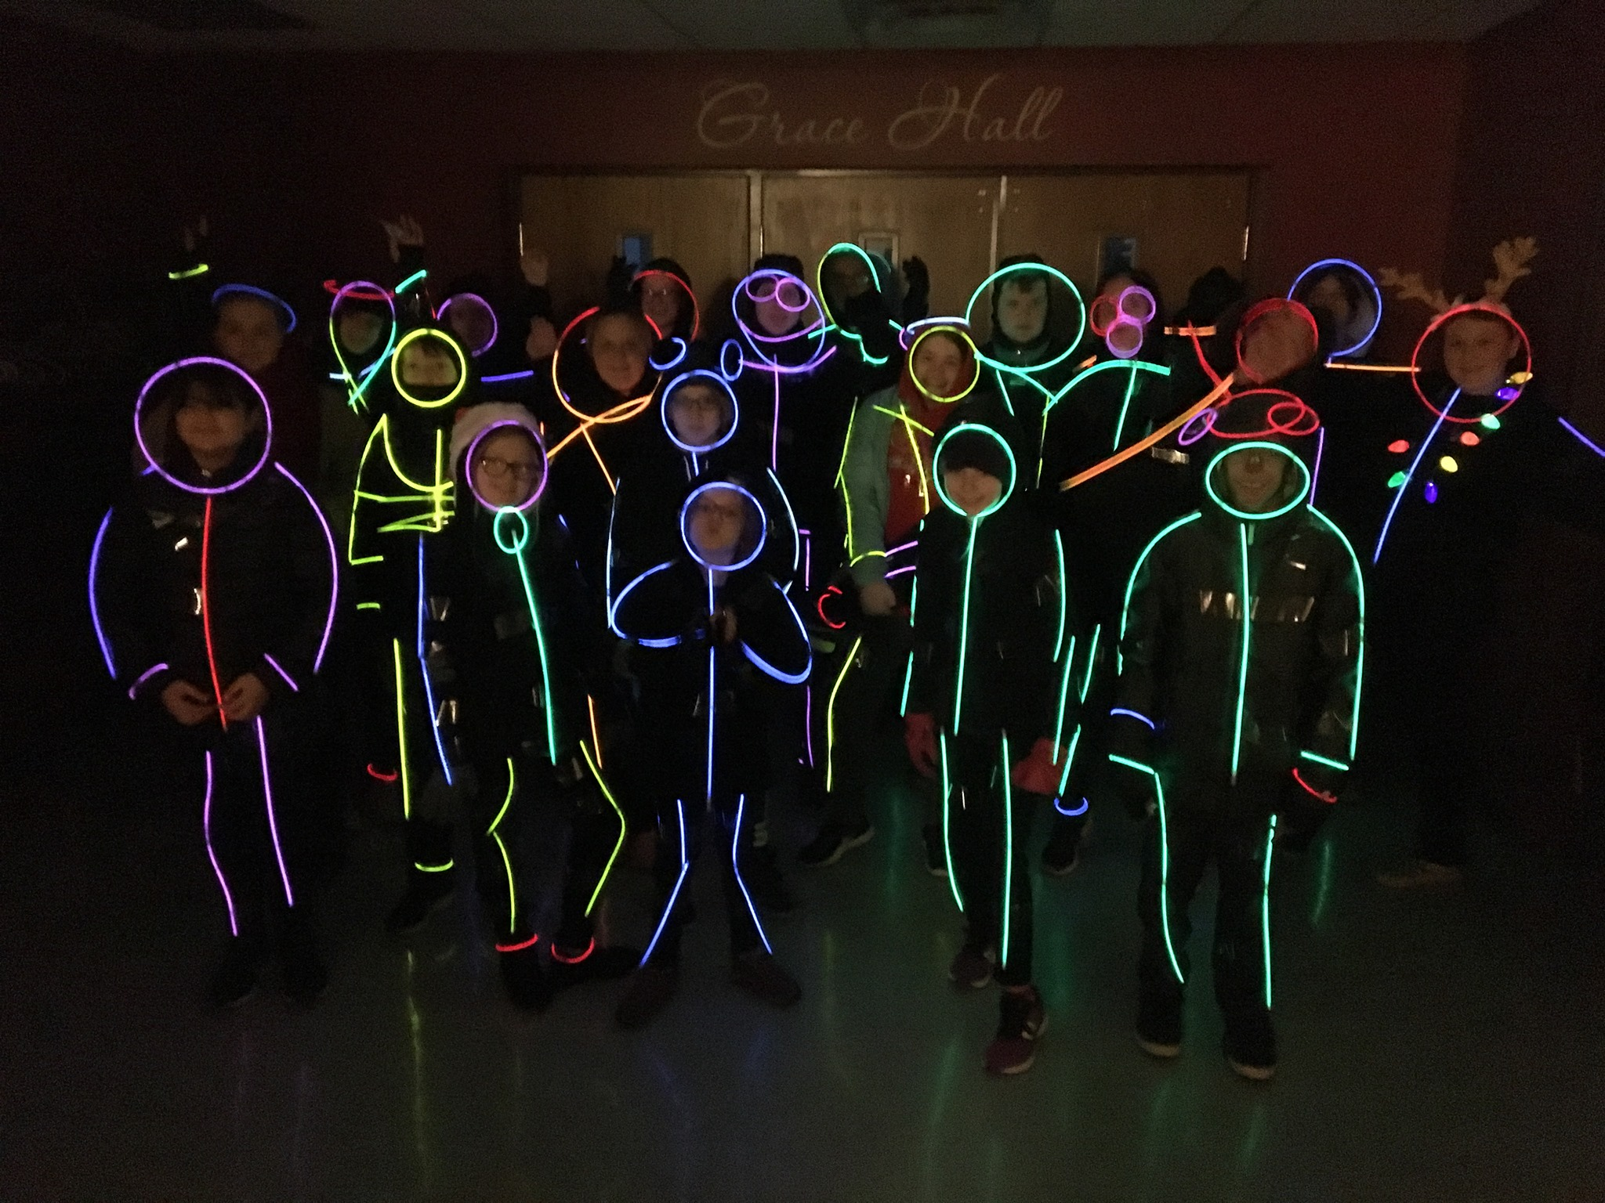

**Early Childhood Music Classes: Ages 0m-1st G!**

Our music classes for younger musicians **are still looking for registrants!** Family Music (0m-3yo) and *musique joyeuse* (4yo-1st Grade) are classes that follow the Musikgarten Curriculum, and are taught by the loveable Mrs. Catherine Rudd. Any friends or family members that would be interested, there is no need to audition!

Have them register at [www.ccccnotes.com](http://www.ccccnotes.com). Thank you!!

**Dynamic Dates:**

**As the season continues, changes will be noted in red.**

**Jan 4:** B’more Blast Game in SECU Arena at TU; G:5p; P:6:05p (O)

**Jan 7:** Rehearsals Resume (M)

**Jan 14:** Chick-fil-a All Day! (O) BYF!

**Feb 11:** Chick-fil-a All Day! (O) BYF!

**Feb 23:** LPVs sing at GL Service, G: 10:45am, P: 11:15am (M)

**March 10:** Open House: Bring a singing friend! (M to attend, O to bring a friend); Chick-fil-a All Day! (O) BYF!

**March 24:** Oscars Fundraiser/Silent Auction All Day!(O)BYF!

**March 22:** DBs Perform First Pres. Church G: 10:30a P:11am (M)

**March 28:** DrummingMusic Workshop, GA from 1-4pm (M)

**April 4:** Snow Day Rehearsal GL (M) 9:45a-11a DBs; 10:15a-11:15a LPVs; 11:15a-12:45p BCIs; 11:30a-1:00p BCIIs

**Apr 14:** Chick-fil-a All Day! (O) BYF!

**Apr 18:** All Choirs Final Rehearsal BMC, MANDATORY (M)

BCI: 9-10:20a, BCII: 9:40-11:15a, LPV: 11:20a-12:10p, DB: 11:55-1p

**Apr 19:** Spring Celebration Concert, G: 2:30p, P: 3p BMC (M)

**Apr 21:** Materials Collection Date (M)

**April 21-June 23:** Tuesday night rehearsals continue Ireland

**May 5:** May Audition for New Members at Grace Lutheran (O)

**June 30-July 7:** Ireland Trip 2020

**Key: (M):** Mandatory; **(O):** Optional;

**GL:** Grace Lutheran Church; **GA:** Gerstell Academy;

**BMC:** Baker Memorial Chapel, McDaniel College;

**BYF:** Bring Your Flyer!